**API End Points and Communication**

**Day 10: 14 March 28**

Creating new spring boot project

Product CRUD Operation : Insert, delete, update and retrieve etc.

Starter -🡪 Web Starter -🡪 web application features

Starter -🡪View , Thymeleaf -🡪 for view purpose

Starter 🡪 JDBC Starter : which provide features as DataSource or JdbcTemplate

Or

Starter -🡪 JPA starter 🡪 which provide core JPA or Spring JPA Data features.

Dependency 🡪 My SQL Connector

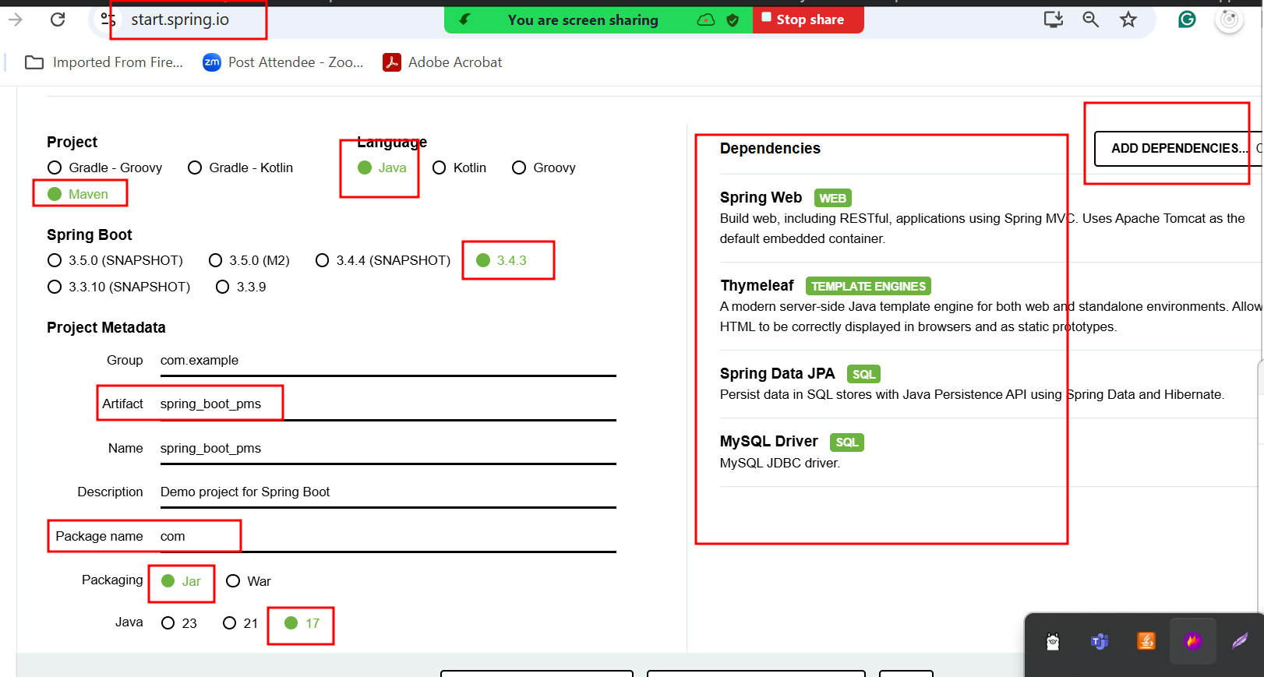

Thymeleaf provide lot of pre defined tags which help to do dynamic work on html page. If we want to use that features first we need to refer to online URL as

<http://www.thymeleaf.org>

spring boot provided one of the pre defined API as Model. which contains some method which help to share the data or information from controller to view as thymeleaf.